**PL SQL PROGRAMMING**

**-- Schema to be Created**

CREATE TABLE CUSTOMERS (

CUSTOMERID NUMBER PRIMARY KEY,

NAME VARCHAR2(100),

DOB DATE,

BALANCE NUMBER,

LASTMODIFIED DATE

);

CREATE TABLE ACCOUNTS (

ACCOUNTID NUMBER PRIMARY KEY,

CUSTOMERID NUMBER,

ACCOUNTTYPE VARCHAR2(20),

BALANCE NUMBER,

LASTMODIFIED DATE,

FOREIGN KEY ( CUSTOMERID )

REFERENCES CUSTOMERS ( CUSTOMERID )

);

CREATE TABLE TRANSACTIONS (

TRANSACTIONID NUMBER PRIMARY KEY,

ACCOUNTID NUMBER,

TRANSACTIONDATE DATE,

AMOUNT NUMBER,

TRANSACTIONTYPE VARCHAR2(10),

FOREIGN KEY ( ACCOUNTID )

REFERENCES ACCOUNTS ( ACCOUNTID )

);

CREATE TABLE LOANS (

LOANID NUMBER PRIMARY KEY,

CUSTOMERID NUMBER,

LOANAMOUNT NUMBER,

INTERESTRATE NUMBER,

STARTDATE DATE,

ENDDATE DATE,

FOREIGN KEY ( CUSTOMERID )

REFERENCES CUSTOMERS ( CUSTOMERID )

);

**OUTPUT:**

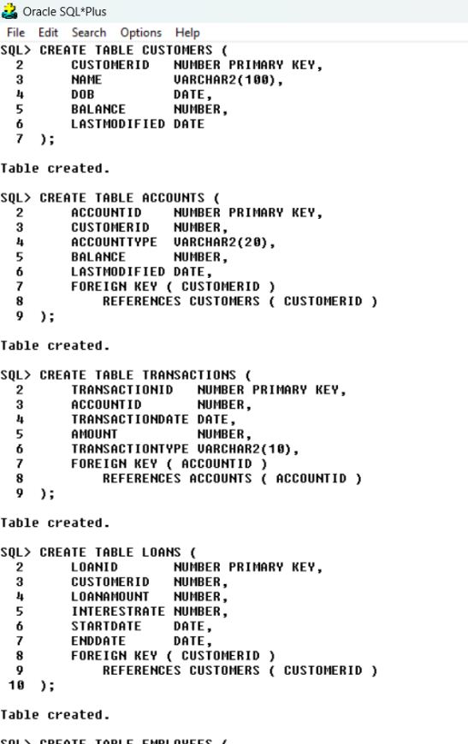

CREATE TABLE EMPLOYEES (

EMPLOYEEID NUMBER PRIMARY KEY,

NAME VARCHAR2(100),

POSITION VARCHAR2(50),

SALARY NUMBER,

DEPARTMENT VARCHAR2(50),

HIREDATE DATE

);

**OUTPUT:**

**-- Example Scripts for Sample Data Insertion**

-- INSERT INTO CUSTOMERS

INSERT INTO CUSTOMERS (CUSTOMERID, NAME, DOB, BALANCE, LASTMODIFIED)

VALUES (1, 'John Doe', TO_DATE('1985-05-15', 'YYYY-MM-DD'), 1000, SYSDATE);

INSERT INTO CUSTOMERS (CUSTOMERID, NAME, DOB, BALANCE, LASTMODIFIED)

VALUES (2, 'Jane Smith', TO_DATE('1990-07-20', 'YYYY-MM-DD'), 1500, SYSDATE);

-- INSERT INTO ACCOUNTS

INSERT INTO ACCOUNTS (ACCOUNTID, CUSTOMERID, ACCOUNTTYPE, BALANCE, LASTMODIFIED)

VALUES (1, 1, 'Savings', 1000, SYSDATE);

INSERT INTO ACCOUNTS (ACCOUNTID, CUSTOMERID, ACCOUNTTYPE, BALANCE, LASTMODIFIED)

VALUES (2, 2, 'Checking', 1500, SYSDATE);

-- INSTER INTO TRANSACTIONS

INSERT INTO TRANSACTIONS (TRANSACTIONID, ACCOUNTID, TRANSACTIONDATE, AMOUNT, TRANSACTIONTYPE)

VALUES (1, 1, SYSDATE, 200, 'Deposit');

INSERT INTO TRANSACTIONS (TRANSACTIONID, ACCOUNTID, TRANSACTIONDATE, AMOUNT, TRANSACTIONTYPE)

VALUES (2, 2, SYSDATE, 300, 'Withdrawal');

-- INSERT INTO LOANS

INSERT INTO LOANS (LOANID, CUSTOMERID, LOANAMOUNT, INTERESTRATE, STARTDATE, ENDDATE)

VALUES (1, 1, 5000, 5, SYSDATE, ADD_MONTHS(SYSDATE, 60));

-- INSERT INTO EMPLOYEES

INSERT INTO EMPLOYEES (EMPLOYEEID, NAME, POSITION, SALARY, DEPARTMENT, HIREDATE)

VALUES (1, 'Alice Johnson', 'Manager', 70000, 'HR', TO_DATE('2015-06-15', 'YYYY-MM-DD'));

INSERT INTO EMPLOYEES (EMPLOYEEID, NAME, POSITION, SALARY, DEPARTMENT, HIREDATE)

VALUES (2, 'Bob Brown', 'Developer', 60000, 'IT', TO_DATE('2017-03-20', 'YYYY-MM-DD'));

**OUTPUT:**

**-- QUESTIONS AND SOLUTIONS**

**Exercise 1: Control Structures**

Scenario 1: The bank wants to apply a discount to loan interest rates for customers above 60 years old.

? Question: Write a PL/SQL block that loops through all customers, checks their age,

and if they are above 60, apply a 1% discount to their current loan interest rates.

Scenario 2: A customer can be promoted to VIP status based on their balance.

? Question: Write a PL/SQL block that iterates through all customers and sets a flag IsVIP to TRUE

for those with a balance over $10,000.

Scenario 3: The bank wants to send reminders to customers whose loans are due within the next 30 days.

? Question: Write a PL/SQL block that fetches all loans due in the next 30 days and prints a reminder

message for each customer.

**-- SCENARIO 1**

SET SERVEROUTPUT ON;

DECLARE

CURSOR CUSTOMER_CURSOR IS

SELECT CUSTOMERID, EXTRACT(YEAR FROM SYSDATE) - EXTRACT(YEAR FROM DOB) AS AGE

FROM CUSTOMERS;

VAR_CUSTOMER_ID CUSTOMERS.CUSTOMERID%TYPE;

VAR_AGE NUMBER;

BEGIN

FOR CUSTOMER_RECORD IN CUSTOMER_CURSOR LOOP

VAR_CUSTOMER_ID := CUSTOMER_RECORD.CUSTOMERID;

VAR_AGE := CUSTOMER_RECORD.AGE;

IF VAR_AGE > 60 THEN

UPDATE LOANS

SET INTERESTRATE = INTERESTRATE - 1

WHERE CUSTOMERID = VAR_CUSTOMER_ID;

ELSE

DBMS_OUTPUT.PUT_LINE('CUSTOMER WITH CUSTOMER ID : ' || VAR_CUSTOMER_ID || ' IS OF AGE : ' || VAR_AGE);

DBMS_OUTPUT.PUT_LINE('NO CHANGE IN LOAN');

END IF;

END LOOP;

COMMIT;

END;

/

**OUTPUT:**

**-- SCENARIO 2**

DESC CUSTOMERS;

ALTER TABLE CUSTOMERS ADD ISVIP CHAR(10) CONSTRAINT CHK1 CHECK(ISVIP IN ('TRUE','FALSE')) ;

SET SERVEROUTPUT ON;

DECLARE

CURSOR CUSTOMER_CURSOR IS

SELECT CUSTOMERID, BALANCE

FROM CUSTOMERS;

VAR_CUSTOMER_ID CUSTOMERS.CUSTOMERID%TYPE;

VAR_BALANCE CUSTOMERS.BALANCE%TYPE;

BEGIN

FOR CUSTOMER_RECORD IN CUSTOMER_CURSOR LOOP

VAR_CUSTOMER_ID := CUSTOMER_RECORD.CUSTOMERID;

VAR_BALANCE := CUSTOMER_RECORD.BALANCE;

IF VAR_BALANCE > 10000 THEN

DBMS_OUTPUT.PUT_LINE('CUSTOMER ID : ' || VAR_CUSTOMER_ID || ' HAS BALANCE GREATER THAN 10000');

UPDATE CUSTOMERS

SET ISVIP = 'TRUE'

WHERE CUSTOMERID = VAR_CUSTOMER_ID;

ELSE

DBMS_OUTPUT.PUT_LINE('CUSTOMER ID : ' || VAR_CUSTOMER_ID || ' HAS BALANCE LESSER THAN 10000');

UPDATE CUSTOMERS

SET ISVIP = 'FALSE'

WHERE CUSTOMERID = VAR_CUSTOMER_ID;

END IF;

END LOOP;

COMMIT;

END;

/

**OUTPUT:**

**-- SCENARIO 3**

SET SERVEROUTPUT ON;

DECLARE

CURSOR CUR_LOANS IS

SELECT L.LOANID, L.CUSTOMERID, C.NAME, L.ENDDATE

FROM LOANS L

JOIN CUSTOMERS C ON L.CUSTOMERID = C.CUSTOMERID

WHERE L.ENDDATE BETWEEN SYSDATE AND SYSDATE + 30;

V_LOAN_ID LOANS.LOANID%TYPE;

V_CUSTOMER_ID LOANS.CUSTOMERID%TYPE;

V_CUSTOMER_NAME CUSTOMERS.NAME%TYPE;

V_END_DATE LOANS.ENDDATE%TYPE;

V_FOUND BOOLEAN := FALSE;

BEGIN

OPEN CUR_LOANS;

LOOP

FETCH CUR_LOANS INTO V_LOAN_ID, V_CUSTOMER_ID, V_CUSTOMER_NAME, V_END_DATE;

EXIT WHEN CUR_LOANS%NOTFOUND;

V_FOUND := TRUE;

DBMS_OUTPUT.PUT_LINE('Reminder: Loan ' || V_LOAN_ID || ' for customer ' || V_CUSTOMER_NAME || ' (ID: ' || V_CUSTOMER_ID || ') is due on ' || TO_CHAR(V_END_DATE, 'YYYY-MM-DD'));

END LOOP;

CLOSE CUR_LOANS;

IF NOT V_FOUND THEN

DBMS_OUTPUT.PUT_LINE('No loans are due within the next 30 days.');

END IF;

END;

/

**OUTPUT:**

**Exercise 2: Error Handling**

Scenario 1: Handle exceptions during fund transfers between accounts.

? Question: Write a stored procedure SafeTransferFunds that transfers funds between two accounts.

Ensure that if any error occurs (e.g., insufficient funds), an appropriate error message is logged

and the transaction is rolled back.

Scenario 2: Manage errors when updating employee salaries.

? Question: Write a stored procedure UpdateSalary that increases the salary of an employee by a given percentage.

If the employee ID does not exist, handle the exception and log an error message.

Scenario 3: Ensure data integrity when adding a new customer.

? Question: Write a stored procedure AddNewCustomer that inserts a new customer into the Customers table.

If a customer with the same ID already exists, handle the exception by logging an error and preventing

the insertion.

**-- SCENARIO 1**

SET SERVEROUTPUT ON;

CREATE OR REPLACE PROCEDURE SAFETRANSFERFUNDS(

P_FROM_ACCOUNT_ID IN ACCOUNTS.ACCOUNTID%TYPE,

P_TO_ACCOUNT_ID IN ACCOUNTS.ACCOUNTID%TYPE,

P_AMOUNT IN NUMBER

) AS

V_FROM_BALANCE ACCOUNTS.BALANCE%TYPE;

V_TO_BALANCE ACCOUNTS.BALANCE%TYPE;

BEGIN

SELECT BALANCE INTO V_FROM_BALANCE

FROM ACCOUNTS

WHERE ACCOUNTID = P_FROM_ACCOUNT_ID

FOR UPDATE;

SELECT BALANCE INTO V_TO_BALANCE

FROM ACCOUNTS

WHERE ACCOUNTID = P_TO_ACCOUNT_ID

FOR UPDATE;

-- Check for sufficient funds

IF V_FROM_BALANCE < P_AMOUNT THEN

RAISE_APPLICATION_ERROR(-20001, 'Insufficient funds in the source account.');

END IF;

-- Perform the transfer

UPDATE ACCOUNTS

SET BALANCE = BALANCE - P_AMOUNT,

LASTMODIFIED = SYSDATE

WHERE ACCOUNTID = P_FROM_ACCOUNT_ID;

UPDATE ACCOUNTS

SET BALANCE = BALANCE + P_AMOUNT,

LASTMODIFIED = SYSDATE

WHERE ACCOUNTID = P_TO_ACCOUNT_ID;

COMMIT;

DBMS_OUTPUT.PUT_LINE('Transfer successful.');

EXCEPTION

WHEN OTHERS THEN

ROLLBACK;

DBMS_OUTPUT.PUT_LINE('Transfer failed: ' || SQLERRM);

END SAFETRANSFERFUNDS;

/

EXEC SAFETRANSFERFUNDS(2,1,500);

**OUTPUT:**

**-- SCENARIO 2**

SET SERVEROUTPUT ON;

CREATE OR REPLACE PROCEDURE UPDATESALARY(

P_EMPLOYEE_ID IN EMPLOYEES.EMPLOYEEID%TYPE,

P_PERCENTAGE IN NUMBER

) AS

V_OLD_SALARY EMPLOYEES.SALARY%TYPE;

BEGIN

-- Fetch the current salary

SELECT SALARY INTO V_OLD_SALARY

FROM EMPLOYEES

WHERE EMPLOYEEID = P_EMPLOYEE_ID;

-- Update the salary

UPDATE EMPLOYEES

SET SALARY = SALARY * (1 + P_PERCENTAGE / 100),

HIREDATE = SYSDATE

WHERE EMPLOYEEID = P_EMPLOYEE_ID;

COMMIT;

DBMS_OUTPUT.PUT_LINE('Salary updated successfully.');

EXCEPTION

WHEN NO_DATA_FOUND THEN

DBMS_OUTPUT.PUT_LINE('Error: Employee ID ' || P_EMPLOYEE_ID || ' does not exist.');

WHEN OTHERS THEN

ROLLBACK;

DBMS_OUTPUT.PUT_LINE('Salary update failed: ' || SQLERRM);

END UPDATESALARY;

/

EXEC UPDATESALARY(1,5);

EXEC UPDATESALARY(2,3);

**OUTPUT:**

**-- SCENARIO 3**

SET SERVEROUTPUT ON;

CREATE OR REPLACE PROCEDURE ADDNEWCUSTOMER(

P_CUSTOMER_ID IN CUSTOMERS.CUSTOMERID%TYPE,

P_NAME IN CUSTOMERS.NAME%TYPE,

P_DOB IN CUSTOMERS.DOB%TYPE,

P_BALANCE IN CUSTOMERS.BALANCE%TYPE

) AS

BEGIN

-- Attempt to insert the new customer

DBMS_OUTPUT.PUT_LINE('INSERTING...');

DBMS_OUTPUT.PUT_LINE('CUSTOMER_ID : ' || P_CUSTOMER_ID);

DBMS_OUTPUT.PUT_LINE('NAME : ' || P_NAME);

DBMS_OUTPUT.PUT_LINE('DOB : ' || P_DOB);

DBMS_OUTPUT.PUT_LINE('BALANCE : ' || P_BALANCE);

INSERT INTO CUSTOMERS (CUSTOMERID, NAME, DOB, BALANCE, LASTMODIFIED)

VALUES (P_CUSTOMER_ID, P_NAME, TO_DATE(P_DOB,'YYYY-MM-DD'), P_BALANCE, SYSDATE);

COMMIT;

DBMS_OUTPUT.PUT_LINE('Customer added successfully.');

EXCEPTION

WHEN DUP_VAL_ON_INDEX THEN

DBMS_OUTPUT.PUT_LINE('Error: Customer ID ' || P_CUSTOMER_ID || ' already exists.');

WHEN OTHERS THEN

ROLLBACK;

DBMS_OUTPUT.PUT_LINE('Customer addition failed: ' || SQLERRM);

END ADDNEWCUSTOMER;

/

EXEC ADDNEWCUSTOMER(3,'ARKA PRATIM GHOSH','21-10-2002',50000);

**OUTPUT:**

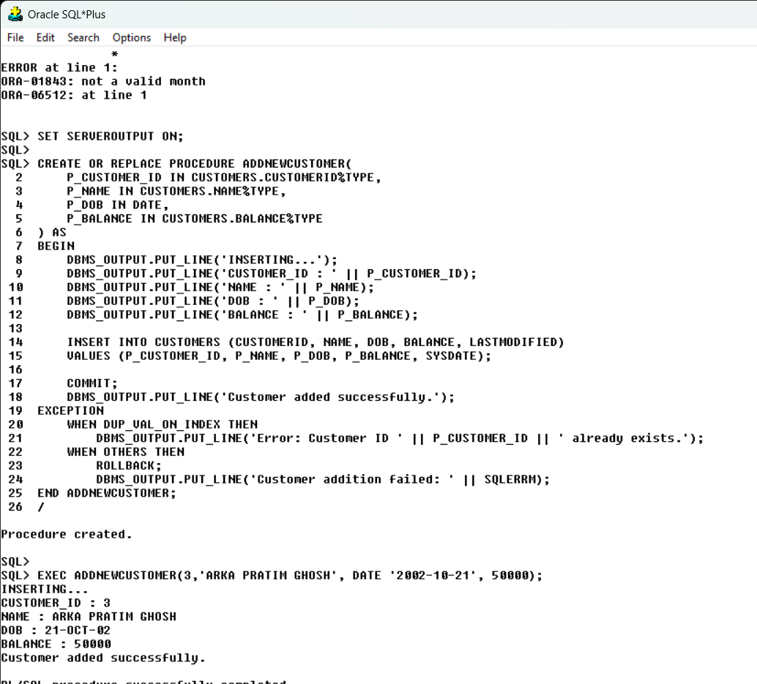

**Exercise 3: Stored Procedures**

Scenario 1: The bank needs to process monthly interest for all savings accounts.

? Question: Write a stored procedure ProcessMonthlyInterest that calculates and

updates the balance of all savings accounts by applying an interest rate of 1% to the current balance.

Scenario 2: The bank wants to implement a bonus scheme for employees based on their performance.

? Question: Write a stored procedure UpdateEmployeeBonus that updates the salary of employees

in a given department by adding a bonus percentage passed as a parameter.

Scenario 3: Customers should be able to transfer funds between their accounts.

? Question: Write a stored procedure TransferFunds that transfers a specified amount from one account to another,

checking that the source account has sufficient balance before making the transfer.

**-- SCENARIO 1**

SET SERVEROUTPUT ON;

CREATE OR REPLACE PROCEDURE PROCESSMONTHLYINTEREST AS

BEGIN

UPDATE ACCOUNTS

SET BALANCE = BALANCE * 1.01,

LASTMODIFIED = SYSDATE

WHERE ACCOUNTTYPE = 'Savings';

COMMIT;

DBMS_OUTPUT.PUT_LINE('Monthly interest processed for all savings accounts.');

EXCEPTION

WHEN OTHERS THEN

ROLLBACK;

DBMS_OUTPUT.PUT_LINE('Error processing monthly interest: ' || SQLERRM);

END PROCESSMONTHLYINTEREST;

/

EXEC PROCESSMONTHLYINTEREST();

**OUTPUT:**

**-- SCENARIO 2**

SET SERVEROUTPUT ON;

CREATE OR REPLACE PROCEDURE UPDATEEMPLOYEEBONUS(

P_DEPARTMENT IN EMPLOYEES.DEPARTMENT%TYPE,

P_BONUS_PERCENTAGE IN NUMBER

) AS

BEGIN

UPDATE EMPLOYEES

SET SALARY = SALARY * (1 + P_BONUS_PERCENTAGE / 100),

HIREDATE = SYSDATE

WHERE DEPARTMENT = P_DEPARTMENT;

COMMIT;

DBMS_OUTPUT.PUT_LINE('Bonus applied to employees in the ' || P_DEPARTMENT || ' department.');

EXCEPTION

WHEN OTHERS THEN

ROLLBACK;

DBMS_OUTPUT.PUT_LINE('Error updating employee bonuses: ' || SQLERRM);

END UPDATEEMPLOYEEBONUS;

/

EXEC UPDATEEMPLOYEEBONUS('IT',5);

EXEC UPDATEEMPLOYEEBONUS('HR',3);

**OUTPUT:**

**-- SCENARIO 3**

SET SERVEROUTPUT ON;

CREATE OR REPLACE PROCEDURE TRANSFERFUNDS(

P_FROM_ACCOUNT_ID IN ACCOUNTS.ACCOUNTID%TYPE,

P_TO_ACCOUNT_ID IN ACCOUNTS.ACCOUNTID%TYPE,

P_AMOUNT IN NUMBER

) AS

V_FROM_BALANCE ACCOUNTS.BALANCE%TYPE;

BEGIN

SELECT BALANCE INTO V_FROM_BALANCE

FROM ACCOUNTS

WHERE ACCOUNTID = P_FROM_ACCOUNT_ID

FOR UPDATE;

-- Check for sufficient funds

IF V_FROM_BALANCE < P_AMOUNT THEN

RAISE_APPLICATION_ERROR(-20001, 'Insufficient funds in the source account.');

END IF;

-- Perform the transfer

UPDATE ACCOUNTS

SET BALANCE = BALANCE - P_AMOUNT,

LASTMODIFIED = SYSDATE

WHERE ACCOUNTID = P_FROM_ACCOUNT_ID;

UPDATE ACCOUNTS

SET BALANCE = BALANCE + P_AMOUNT,

LASTMODIFIED = SYSDATE

WHERE ACCOUNTID = P_TO_ACCOUNT_ID;

COMMIT;

DBMS_OUTPUT.PUT_LINE('Transfer of ' || P_AMOUNT || ' from account ' || P_FROM_ACCOUNT_ID || ' to account ' || P_TO_ACCOUNT_ID || ' completed successfully.');

EXCEPTION

WHEN OTHERS THEN

ROLLBACK;

DBMS_OUTPUT.PUT_LINE('Transfer failed: ' || SQLERRM);

END TRANSFERFUNDS;

/

EXEC TRANSFERFUNDS(1,2,100);

**OUTPUT:**

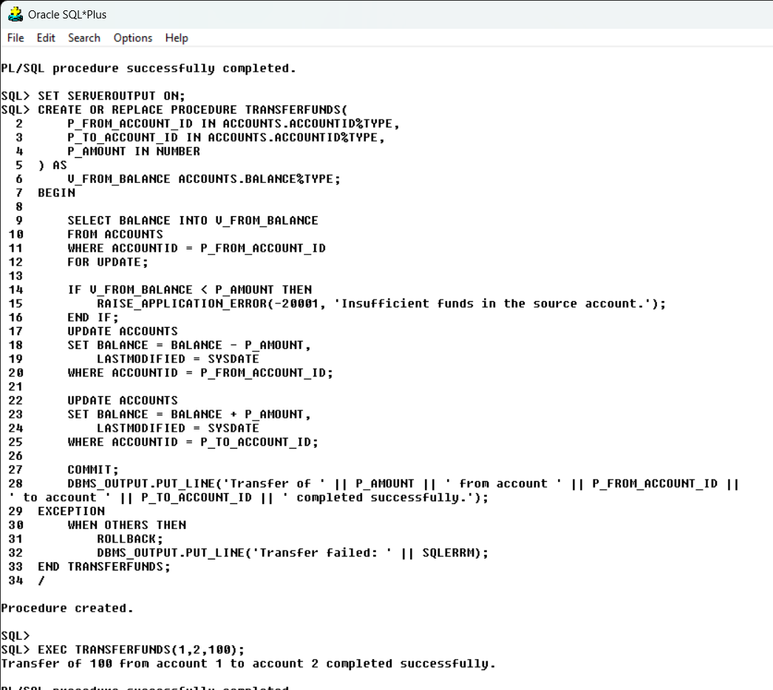

**Exercise 4: Functions**

Scenario 1: Calculate the age of customers for eligibility checks.

? Question: Write a function CalculateAge that takes a customer's date of birth as input and

returns their age in years.

Scenario 2: The bank needs to compute the monthly installment for a loan.

? Question: Write a function CalculateMonthlyInstallment that takes the loan amount, interest rate,

and loan duration in years as input and returns the monthly installment amount.

Scenario 3: Check if a customer has sufficient balance before making a transaction.

? Question: Write a function HasSufficientBalance that takes an account ID and an amount as input and

returns a boolean indicating whether the account has at least the specified amount.

**-- SCENARIO 1**

DELETE FROM CUSTOMERS WHERE CUSTOMERID = 3;

SET SERVEROUTPUT ON;

CREATE OR REPLACE FUNCTION CALCULATEAGE(

P_DOB IN DATE

) RETURN NUMBER IS

V_AGE NUMBER;

BEGIN

V_AGE := TRUNC((SYSDATE - P_DOB) / 365);

RETURN V_AGE;

END CALCULATEAGE;

/

SET SERVEROUTPUT ON;

DECLARE

CURSOR CURSOR_CUST IS SELECT CUSTOMERID, DOB FROM CUSTOMERS;

V_CUSTOMERID CUSTOMERS.CUSTOMERID%TYPE;

V_DOB CUSTOMERS.DOB%TYPE;

V_AGE NUMBER;

BEGIN

OPEN CURSOR_CUST;

LOOP

FETCH CURSOR_CUST INTO V_CUSTOMERID, V_DOB;

EXIT WHEN CURSOR_CUST%NOTFOUND

V_AGE := CALCULATEAGE(V_DOB);

DBMS_OUTPUT.PUT_LINE('CUSTOMER ID : ' || V_CUSTOMERID || ' AGE : ' || V_AGE);

END LOOP;

CLOSE CURSOR_CUST;

END;

/

**OUTPUT:**

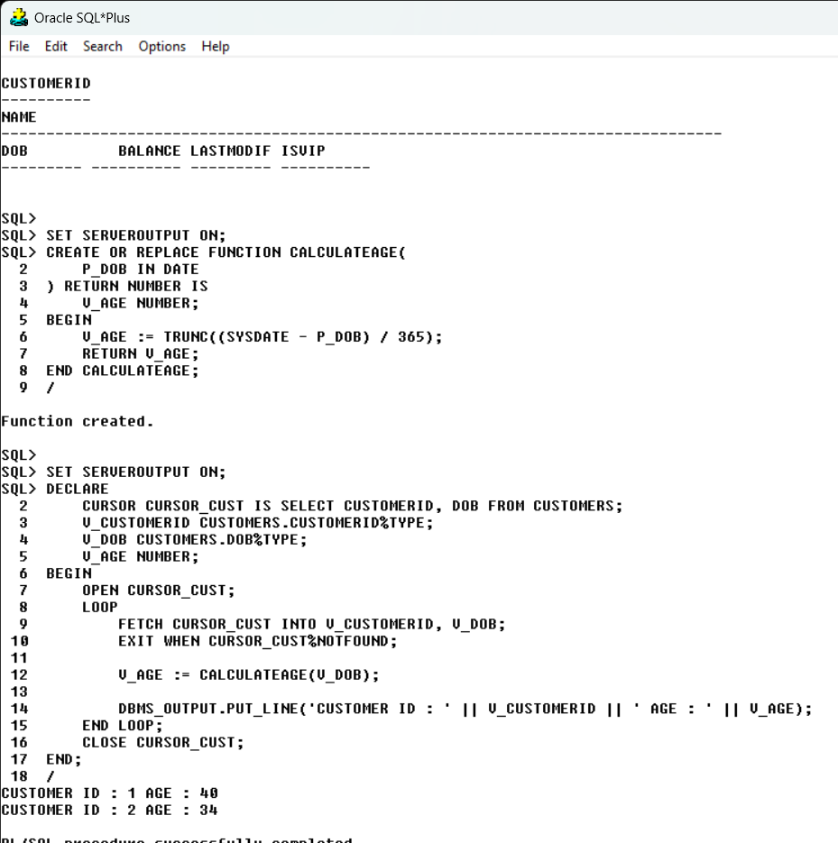

**-- SCENARIO 2**

SET SERVEROUTPUT ON;

CREATE OR REPLACE FUNCTION CALCULATEMONTHLYINSTALLMENT(

P_LOAN_AMOUNT IN NUMBER,

P_INTEREST_RATE IN NUMBER,

P_LOAN_DURATION_YEARS IN NUMBER

) RETURN NUMBER IS

V_MONTHLY_RATE NUMBER;

V_NUM_PAYMENTS NUMBER;

V_MONTHLY_INSTALLMENT NUMBER;

BEGIN

V_MONTHLY_RATE := P_INTEREST_RATE / 12 / 100;

V_NUM_PAYMENTS := P_LOAN_DURATION_YEARS * 12;

IF V_MONTHLY_RATE = 0 THEN

V_MONTHLY_INSTALLMENT := P_LOAN_AMOUNT / V_NUM_PAYMENTS;

ELSE

V_MONTHLY_INSTALLMENT := P_LOAN_AMOUNT * V_MONTHLY_RATE / (1 - POWER(1 + V_MONTHLY_RATE, -V_NUM_PAYMENTS));

END IF;

RETURN V_MONTHLY_INSTALLMENT;

END CALCULATEMONTHLYINSTALLMENT;

/

SET SERVEROUTPUT ON;

DECLARE

CURSOR LOAN_CUR IS SELECT * FROM LOANS;

V_DATA LOANS%ROWTYPE;

V_DURATION NUMBER;

V_MONTHLYINSTALLMENT NUMBER;

BEGIN

OPEN LOAN_CUR;

LOOP

FETCH LOAN_CUR INTO V_DATA;

EXIT WHEN LOAN_CUR%NOTFOUND;

V_DURATION := TRUNC((V_DATA.ENDDATE - V_DATA.STARTDATE)/365);

V_MONTHLYINSTALLMENT := TRUNC(CALCULATEMONTHLYINSTALLMENT(V_DATA.LOANAMOUNT, V_DATA.INTERESTRATE, V_DURATION),2);

DBMS_OUTPUT.PUT_LINE('CUSTOMER ID : ' || V_DATA.CUSTOMERID || ' MONTHLY INSTALLAMENT : ' || V_MONTHLYINSTALLMENT);

END LOOP;

CLOSE LOAN_CUR;

END;

/

**

**-- SCENARIO 3**

SET SERVEROUTPUT ON;

CREATE OR REPLACE FUNCTION HASSUFFICIENTBALANCE(

P_ACCOUNT_ID IN ACCOUNTS.ACCOUNTID%TYPE,

P_AMOUNT IN NUMBER

) RETURN BOOLEAN IS

V_BALANCE ACCOUNTS.BALANCE%TYPE;

BEGIN

SELECT BALANCE INTO V_BALANCE

FROM ACCOUNTS

WHERE ACCOUNTID = P_ACCOUNT_ID;

RETURN V_BALANCE >= P_AMOUNT;

EXCEPTION

WHEN NO_DATA_FOUND THEN

RETURN FALSE;

WHEN OTHERS THEN

RAISE_APPLICATION_ERROR(-20002, 'Error checking balance: ' || SQLERRM);

END HASSUFFICIENTBALANCE;

/

SET SERVEROUTPUT ON;

DECLARE

V_ACCOUNTID ACCOUNTS.ACCOUNTID%TYPE := &ACCOUNTID;

V_AMOUNT NUMBER := &AMOUNT;

V_HAS BOOLEAN;

BEGIN

V_HAS := HASSUFFICIENTBALANCE(V_ACCOUNTID, V_AMOUNT);

IF V_HAS = TRUE THEN DBMS_OUTPUT.PUT_LINE(V_ACCOUNTID || ' HAS SUFFICIENT AMOUNT');

ELSE DBMS_OUTPUT.PUT_LINE(V_ACCOUNTID || ' DOES NOT HAVE SUFFICIENT AMOUNT');

END IF;

END;

/

**OUTPUT:**

**Exercise 5: Triggers**

Scenario 1: Automatically update the last modified date when a customer's record is updated.

? Question: Write a trigger UpdateCustomerLastModified that updates the LastModified column of the Customers

table to the current date whenever a customer's record is updated.

Scenario 2: Maintain an audit log for all transactions.

? Question: Write a trigger LogTransaction that inserts a record into an AuditLog table whenever a

transaction is inserted into the Transactions table.

Scenario 3: Enforce business rules on deposits and withdrawals.

? Question: Write a trigger CheckTransactionRules that ensures withdrawals do not exceed the balance and deposits

are positive before inserting a record into the Transactions table.

**-- SCENARIO 1**

SET SERVEROUTPUT ON;

CREATE OR REPLACE TRIGGER UPDATECUSTOMERLASTMODIFIED

BEFORE UPDATE ON CUSTOMERS

FOR EACH ROW

BEGIN

:NEW.LASTMODIFIED := SYSDATE;

DBMS_OUTPUT.PUT_LINE('LAST MODIFIED UPDATED');

END UPDATECUSTOMERLASTMODIFIED;

/

UPDATE CUSTOMERS SET NAME = 'JOHN DOE' WHERE CUSTOMERID = 1;

**OUTPUT:**

**-- SCENARIO 2**

CREATE TABLE AUDITLOG (

LOGID NUMBER PRIMARY KEY,

TRANSACTIONID NUMBER,

ACCOUNTID NUMBER,

TRANSACTIONDATE DATE,

AMOUNT NUMBER,

TRANSACTIONTYPE VARCHAR2(10),

LOGTIMESTAMP DATE DEFAULT SYSDATE

);

CREATE SEQUENCE AUDITLOG_SEQ

START WITH 1

INCREMENT BY 1;

SET SERVEROUTPUT ON;

CREATE OR REPLACE TRIGGER LOGTRANSACTIONS

AFTER INSERT ON TRANSACTIONS

FOR EACH ROW

BEGIN

INSERT INTO AUDITLOG (LOGID, TRANSACTIONID, ACCOUNTID, TRANSACTIONDATE, AMOUNT, TRANSACTIONTYPE)

VALUES (AUDITLOG_SEQ.NEXTVAL, :NEW.TRANSACTIONID, :NEW.ACCOUNTID, SYSDATE, :NEW.AMOUNT, :NEW.TRANSACTIONTYPE);

DBMS_OUTPUT.PUT_LINE('INSERT SUCCESSFUL');

END LOGTRANSACTIONS;

/

INSERT INTO TRANSACTIONS (TRANSACTIONID, ACCOUNTID, TRANSACTIONDATE, AMOUNT, TRANSACTIONTYPE)

VALUES (6, 2, SYSDATE, 600, 'Deposit');

**OUTPUT:**

**-- SCENARIO 3**

SET SERVEROUTPUT ON;

CREATE OR REPLACE TRIGGER CHECKTRANSACTIONRULES

BEFORE INSERT ON TRANSACTIONS

FOR EACH ROW

DECLARE

V_BALANCE ACCOUNTS.BALANCE%TYPE;

BEGIN

-- Get the current balance of the account

SELECT BALANCE INTO V_BALANCE

FROM ACCOUNTS

WHERE ACCOUNTID = :NEW.ACCOUNTID

FOR UPDATE;

-- Check the transaction type and validate accordingly

IF :NEW.TRANSACTIONTYPE = 'Withdrawal' THEN

IF :NEW.AMOUNT > V_BALANCE THEN

RAISE_APPLICATION_ERROR(-20001, 'Insufficient balance for the withdrawal.');

END IF;

ELSIF :NEW.TRANSACTIONTYPE = 'Deposit' THEN

IF :NEW.AMOUNT <= 0 THEN

RAISE_APPLICATION_ERROR(-20002, 'Deposit amount must be positive.');

END IF;

ELSE

RAISE_APPLICATION_ERROR(-20003, 'Invalid transaction type.');

END IF;

END CHECKTRANSACTIONRULES;

/

INSERT INTO ACCOUNTS (ACCOUNTID, CUSTOMERID, ACCOUNTTYPE, BALANCE, LASTMODIFIED)

VALUES (4, 1, 'Recurring', 3500, SYSDATE);

**OUTPUT:**

**Exercise 6: Cursors**

Scenario 1: Generate monthly statements for all customers.

? Question: Write a PL/SQL block using an explicit cursor GenerateMonthlyStatements that retrieves all

transactions for the current month and prints a statement for each customer.

Scenario 2: Apply annual fee to all accounts.

? Question: Write a PL/SQL block using an explicit cursor ApplyAnnualFee that deducts an annual maintenance

fee from the balance of all accounts.

Scenario 3: Update the interest rate for all loans based on a new policy.

? Question: Write a PL/SQL block using an explicit cursor UpdateLoanInterestRates that fetches all loans and

updates their interest rates based on the new policy.

*/

**-- SCENARIO 1**

SET SERVEROUTPUT ON;

DECLARE

CURSOR CUR_MONTHLY_TRANSACTIONS IS

SELECT C.CUSTOMERID, C.NAME, T.TRANSACTIONDATE, T.AMOUNT, T.TRANSACTIONTYPE

FROM CUSTOMERS C

JOIN ACCOUNTS A ON C.CUSTOMERID = A.CUSTOMERID

JOIN TRANSACTIONS T ON A.ACCOUNTID = T.ACCOUNTID

WHERE TRUNC(T.TRANSACTIONDATE, 'MM') = TRUNC(SYSDATE, 'MM')

ORDER BY C.CUSTOMERID, T.TRANSACTIONDATE;

V_CUSTOMER_ID CUSTOMERS.CUSTOMERID%TYPE;

V_CUSTOMER_NAME CUSTOMERS.NAME%TYPE;

V_TRANSACTION_DATE TRANSACTIONS.TRANSACTIONDATE%TYPE;

V_AMOUNT TRANSACTIONS.AMOUNT%TYPE;

V_TRANSACTION_TYPE TRANSACTIONS.TRANSACTIONTYPE%TYPE;

BEGIN

OPEN CUR_MONTHLY_TRANSACTIONS;

LOOP

FETCH CUR_MONTHLY_TRANSACTIONS INTO V_CUSTOMER_ID, V_CUSTOMER_NAME, V_TRANSACTION_DATE, V_AMOUNT, V_TRANSACTION_TYPE;

EXIT WHEN CUR_MONTHLY_TRANSACTIONS%NOTFOUND;

DBMS_OUTPUT.PUT_LINE('Customer ID: ' || V_CUSTOMER_ID || ', Name: ' || V_CUSTOMER_NAME);

DBMS_OUTPUT.PUT_LINE('Transaction Date: ' || TO_CHAR(V_TRANSACTION_DATE, 'YYYY-MM-DD') || ', Amount: ' || V_AMOUNT || ', Type: ' || V_TRANSACTION_TYPE);

END LOOP;

CLOSE CUR_MONTHLY_TRANSACTIONS;

END;

/

**OUTPUT:**

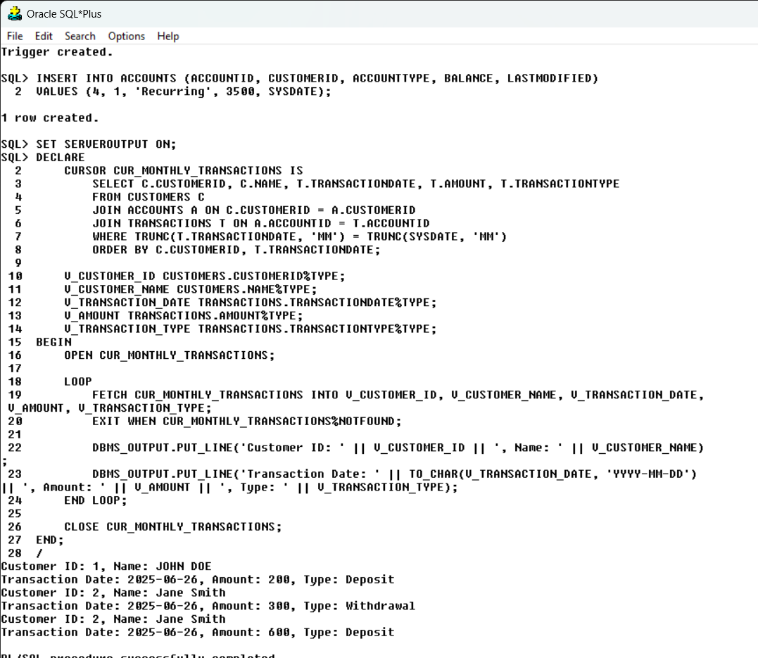

**-- SCENARIO 2**

SET SERVEROUTPUT ON;

DECLARE

CURSOR CUR_ACCOUNTS IS

SELECT ACCOUNTID, BALANCE

FROM ACCOUNTS;

V_ACCOUNT_ID ACCOUNTS.ACCOUNTID%TYPE;

V_BALANCE ACCOUNTS.BALANCE%TYPE;

V_ANNUAL_FEE CONSTANT NUMBER := 50; -- Annual fee amount

BEGIN

OPEN CUR_ACCOUNTS;

LOOP

FETCH CUR_ACCOUNTS INTO V_ACCOUNT_ID, V_BALANCE;

EXIT WHEN CUR_ACCOUNTS%NOTFOUND;

UPDATE ACCOUNTS

SET BALANCE = BALANCE - V_ANNUAL_FEE,

LASTMODIFIED = SYSDATE

WHERE ACCOUNTID = V_ACCOUNT_ID;

DBMS_OUTPUT.PUT_LINE('Annual fee of ' || V_ANNUAL_FEE || ' deducted from Account ID: ' || V_ACCOUNT_ID);

END LOOP;

CLOSE CUR_ACCOUNTS;

COMMIT;

END;

/

**OUTPUT:**

**-- SCENARIO 3**

SET SERVEROUTPUT ON;

DECLARE

CURSOR CUR_LOANS IS

SELECT LOANID, INTERESTRATE

FROM LOANS;

V_LOAN_ID LOANS.LOANID%TYPE;

V_INTEREST_RATE LOANS.INTERESTRATE%TYPE;

V_NEW_INTEREST_RATE NUMBER;

V_NEW_POLICY NUMBER := 2;

FUNCTION CALCULATENEWINTERESTRATE(OLD_RATE NUMBER) RETURN NUMBER IS

BEGIN

RETURN OLD_RATE * (1 + (V_NEW_POLICY / 100));

END CALCULATENEWINTERESTRATE;

BEGIN

OPEN CUR_LOANS;

LOOP

FETCH CUR_LOANS INTO V_LOAN_ID, V_INTEREST_RATE;

EXIT WHEN CUR_LOANS%NOTFOUND;

V_NEW_INTEREST_RATE := CALCULATENEWINTERESTRATE(V_INTEREST_RATE);

UPDATE LOANS

SET INTERESTRATE = V_NEW_INTEREST_RATE

WHERE LOANID = V_LOAN_ID;

DBMS_OUTPUT.PUT_LINE('Loan ID: ' || V_LOAN_ID || ' interest rate updated to ' || V_NEW_INTEREST_RATE);

END LOOP;

CLOSE CUR_LOANS;

COMMIT;

END;

/

**OUTPUT:**

**Exercise 7: Packages**

Scenario 1: Group all customer-related procedures and functions into a package.

? Question: Create a package CustomerManagement with procedures for adding a new customer,

updating customer details, and a function to get customer balance.

Scenario 2: Create a package to manage employee data.

? Question: Write a package EmployeeManagement with procedures to hire new employees, update employee details,

and a function to calculate annual salary.

Scenario 3: Group all account-related operations into a package.

? Question: Create a package AccountOperations with procedures for opening a new account, closing an account,

and a function to get the total balance of a customer across all accounts.

**-- SCENARIO 1**

SET SERVEROUTPUT ON;

CREATE OR REPLACE PACKAGE CustomerManagement IS

PROCEDURE AddNewCustomer(

p_customer_id IN CUSTOMERS.CUSTOMERID%TYPE,

p_name IN CUSTOMERS.NAME%TYPE,

p_dob IN CUSTOMERS.DOB%TYPE,

p_balance IN CUSTOMERS.BALANCE%TYPE

);

PROCEDURE UpdateCustomerDetails(

p_customer_id IN CUSTOMERS.CUSTOMERID%TYPE,

p_name IN CUSTOMERS.NAME%TYPE,

p_dob IN CUSTOMERS.DOB%TYPE,

p_balance IN CUSTOMERS.BALANCE%TYPE

);

FUNCTION GetCustomerBalance(

p_customer_id IN CUSTOMERS.CUSTOMERID%TYPE

) RETURN CUSTOMERS.BALANCE%TYPE;

END CustomerManagement;

/

SET SERVEROUTPUT ON;

CREATE OR REPLACE PACKAGE BODY CUSTOMERMANAGEMENT IS

PROCEDURE ADDNEWCUSTOMER(

P_CUSTOMER_ID IN CUSTOMERS.CUSTOMERID%TYPE,

P_NAME IN CUSTOMERS.NAME%TYPE,

P_DOB IN CUSTOMERS.DOB%TYPE,

P_BALANCE IN CUSTOMERS.BALANCE%TYPE

) IS

BEGIN

INSERT INTO CUSTOMERS (CUSTOMERID, NAME, DOB, BALANCE, LASTMODIFIED)

VALUES (P_CUSTOMER_ID, P_NAME, P_DOB, P_BALANCE, SYSDATE);

END ADDNEWCUSTOMER;

PROCEDURE UPDATECUSTOMERDETAILS(

P_CUSTOMER_ID IN CUSTOMERS.CUSTOMERID%TYPE,

P_NAME IN CUSTOMERS.NAME%TYPE,

P_DOB IN CUSTOMERS.DOB%TYPE,

P_BALANCE IN CUSTOMERS.BALANCE%TYPE

) IS

BEGIN

UPDATE CUSTOMERS

SET NAME = P_NAME,

DOB = P_DOB,

BALANCE = P_BALANCE,

LASTMODIFIED = SYSDATE

WHERE CUSTOMERID = P_CUSTOMER_ID;

END UPDATECUSTOMERDETAILS;

FUNCTION GETCUSTOMERBALANCE(

P_CUSTOMER_ID IN CUSTOMERS.CUSTOMERID%TYPE

) RETURN CUSTOMERS.BALANCE%TYPE IS

V_BALANCE CUSTOMERS.BALANCE%TYPE;

BEGIN

SELECT BALANCE INTO V_BALANCE

FROM CUSTOMERS

WHERE CUSTOMERID = P_CUSTOMER_ID;

RETURN V_BALANCE;

END GETCUSTOMERBALANCE;

END CUSTOMERMANAGEMENT;

/

**OUTPUT:**

**-- SCENARIO 2**

SET SERVEROUTPUT ON;

CREATE OR REPLACE PACKAGE EMPLOYEEMANAGEMENT IS

PROCEDURE HIREEMPLOYEE(

P_EMPLOYEE_ID IN EMPLOYEES.EMPLOYEEID%TYPE,

P_NAME IN EMPLOYEES.NAME%TYPE,

P_POSITION IN EMPLOYEES.POSITION%TYPE,

P_SALARY IN EMPLOYEES.SALARY%TYPE,

P_DEPARTMENT IN EMPLOYEES.DEPARTMENT%TYPE,

P_HIRE_DATE IN EMPLOYEES.HIREDATE%TYPE

);

PROCEDURE UPDATEEMPLOYEEDETAILS(

P_EMPLOYEE_ID IN EMPLOYEES.EMPLOYEEID%TYPE,

P_NAME IN EMPLOYEES.NAME%TYPE,

P_POSITION IN EMPLOYEES.POSITION%TYPE,

P_SALARY IN EMPLOYEES.SALARY%TYPE,

P_DEPARTMENT IN EMPLOYEES.DEPARTMENT%TYPE

);

FUNCTION CALCULATEANNUALSALARY(

P_EMPLOYEE_ID IN EMPLOYEES.EMPLOYEEID%TYPE

) RETURN NUMBER;

END EMPLOYEEMANAGEMENT;

/

SET SERVEROUTPUT ON;

CREATE OR REPLACE PACKAGE BODY EMPLOYEEMANAGEMENT IS

PROCEDURE HIREEMPLOYEE(

P_EMPLOYEE_ID IN EMPLOYEES.EMPLOYEEID%TYPE,

P_NAME IN EMPLOYEES.NAME%TYPE,

P_POSITION IN EMPLOYEES.POSITION%TYPE,

P_SALARY IN EMPLOYEES.SALARY%TYPE,

P_DEPARTMENT IN EMPLOYEES.DEPARTMENT%TYPE,

P_HIRE_DATE IN EMPLOYEES.HIREDATE%TYPE

) IS

BEGIN

INSERT INTO EMPLOYEES (EMPLOYEEID, NAME, POSITION, SALARY, DEPARTMENT, HIREDATE)

VALUES (P_EMPLOYEE_ID, P_NAME, P_POSITION, P_SALARY, P_DEPARTMENT, P_HIRE_DATE);

END HIREEMPLOYEE;

PROCEDURE UPDATEEMPLOYEEDETAILS(

P_EMPLOYEE_ID IN EMPLOYEES.EMPLOYEEID%TYPE,

P_NAME IN EMPLOYEES.NAME%TYPE,

P_POSITION IN EMPLOYEES.POSITION%TYPE,

P_SALARY IN EMPLOYEES.SALARY%TYPE,

P_DEPARTMENT IN EMPLOYEES.DEPARTMENT%TYPE

) IS

BEGIN

UPDATE EMPLOYEES

SET NAME = P_NAME,

POSITION = P_POSITION,

SALARY = P_SALARY,

DEPARTMENT = P_DEPARTMENT

WHERE EMPLOYEEID = P_EMPLOYEE_ID;

END UPDATEEMPLOYEEDETAILS;

FUNCTION CALCULATEANNUALSALARY(

P_EMPLOYEE_ID IN EMPLOYEES.EMPLOYEEID%TYPE

) RETURN NUMBER IS

V_SALARY EMPLOYEES.SALARY%TYPE;

BEGIN

SELECT SALARY INTO V_SALARY

FROM EMPLOYEES

WHERE EMPLOYEEID = P_EMPLOYEE_ID;

RETURN V_SALARY * 12; -- Assuming salary is monthly

END CALCULATEANNUALSALARY;

END EMPLOYEEMANAGEMENT;

/

**OUTPUT:**

**-- SCENARIO 3**

SET SERVEROUTPUT ON;

CREATE OR REPLACE PACKAGE ACCOUNTOPERATIONS IS

PROCEDURE OPENNEWACCOUNT(

P_ACCOUNT_ID IN ACCOUNTS.ACCOUNTID%TYPE,

P_CUSTOMER_ID IN ACCOUNTS.CUSTOMERID%TYPE,

P_ACCOUNT_TYPE IN ACCOUNTS.ACCOUNTTYPE%TYPE,

P_BALANCE IN ACCOUNTS.BALANCE%TYPE

);

PROCEDURE CLOSEACCOUNT(

P_ACCOUNT_ID IN ACCOUNTS.ACCOUNTID%TYPE

);

FUNCTION GETTOTALBALANCE(

P_CUSTOMER_ID IN ACCOUNTS.CUSTOMERID%TYPE

) RETURN NUMBER;

END ACCOUNTOPERATIONS;

/

SET SERVEROUTPUT ON;

CREATE OR REPLACE PACKAGE BODY ACCOUNTOPERATIONS IS

PROCEDURE OPENNEWACCOUNT(

P_ACCOUNT_ID IN ACCOUNTS.ACCOUNTID%TYPE,

P_CUSTOMER_ID IN ACCOUNTS.CUSTOMERID%TYPE,

P_ACCOUNT_TYPE IN ACCOUNTS.ACCOUNTTYPE%TYPE,

P_BALANCE IN ACCOUNTS.BALANCE%TYPE

) IS

BEGIN

INSERT INTO ACCOUNTS (ACCOUNTID, CUSTOMERID, ACCOUNTTYPE, BALANCE, LASTMODIFIED)

VALUES (P_ACCOUNT_ID, P_CUSTOMER_ID, P_ACCOUNT_TYPE, P_BALANCE, SYSDATE);

END OPENNEWACCOUNT;

PROCEDURE CLOSEACCOUNT(

P_ACCOUNT_ID IN ACCOUNTS.ACCOUNTID%TYPE

) IS

BEGIN

DELETE FROM ACCOUNTS

WHERE ACCOUNTID = P_ACCOUNT_ID;

END CLOSEACCOUNT;

FUNCTION GETTOTALBALANCE(

P_CUSTOMER_ID IN ACCOUNTS.CUSTOMERID%TYPE

) RETURN NUMBER IS

V_TOTAL_BALANCE NUMBER;

BEGIN

SELECT SUM(BALANCE) INTO V_TOTAL_BALANCE

FROM ACCOUNTS

WHERE CUSTOMERID = P_CUSTOMER_ID;

RETURN V_TOTAL_BALANCE;

END GETTOTALBALANCE;

END ACCOUNTOPERATIONS;

/

**OUTPUT:**

